**Name & ID**: **bk08432** **Date:** 10/09/2024

|  |
| --- |
| **EE-424L Data Communication & Networking**  **Fall 2024**  **Habib University**  **Dhanani School of Science & Engineering** |

LAB 4: **VLAN Configuration and Trunking on Packet Tracer**

|  |  |  |  |  |  |  |  |  |  |  |  |  |  |  |  |  |  |  |  |  |  |  |  |  |  |  |  |
| --- | --- | --- | --- | --- | --- | --- | --- | --- | --- | --- | --- | --- | --- | --- | --- | --- | --- | --- | --- | --- | --- | --- | --- | --- | --- | --- | --- |
| **Lab #4 Marks distribution:**   |  |  |  |  |  |  | | --- | --- | --- | --- | --- | --- | |  |  | **LR2=30** | **LR5=40** | **LR9=10** | **AR4=20** | | **In-Lab Tasks** | **Task 1** | /10 | /15 | /10 | /20 | | **Task 2** | /10 | /15 | | **Post-Lab** | **Task 1** | /10 | /10 | | **Marks Obt.** | **/100** | | | | |  |  |  | | --- | --- | | o**bjectives** | **The objective of this lab is to design and implement a network using Packet Tracer, configure Virtual Local Area Network (VLANs), and verify their functionality through network testing and analysis.** | |

**In-Lab Tasks:**

|  |
| --- |
| **Task 1: Implementation of VLAN on Packet Tracer (Topology 1)** |
| **Task 2: Implementation of VLAN on Packet Tracer (Topology 2)** |

**Introduction**

**VLANs**

Virtual LANs (VLANs) allow network administrators to subdivide a physical network into separate logical broadcast domains. On a standard Layer 2 network, all hosts connected to a switch are members of the same broadcast domain; and broadcast domains can only be physically separated across different switches by routers.

A VLAN represents a broadcast domain. VLANs are identified by a VLAN ID (a number between 0 – 4095), with the default VLAN on any network being VLAN 1. Each port on a switch or router can be assigned to be a member of a VLAN (i.e., to allow receiving and sending traffic on that VLAN). For example: on a switch, traffic that is sent to a port that is a member of VLAN 100, may be forwarded to any other VLAN 100 port on the switch, and it can also travel across a trunk port (connections between switches) to another switch and forwarded to all VLAN 100 ports on that switch. Traffic won't, however, be forwarded to ports that are on a different VLAN ID. This effectively allows a network administrator to logically split up a switch, allowing multiple broadcast domains to coexist on the same hardware, but maintaining the isolation, security, and performance benefits of using completely separate switches**.**

To understand VLAN more clearly let's take an example.

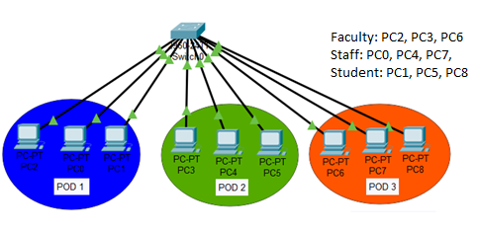

Our campus has three pods. All pods are connected with back links via switch. In each pod, there are some Faculty, Staff and Students PCs available.

* Campus has mainly three departments Faculty, Staff and Students
* Faculty department has three computers.
* Staff department has three computers.
* Students department also has three computers.
* Each pod has one PC from faculty and one from both staff and students department.
* Faculty and Staff department have sensitive information and need to be separate from Students department.

With default configuration, all computers share same broadcast domain. All departments can share the resources. With VLAN we could create logical boundaries over the physical network. Assume that we created three VLANs for our network and assigned them to the related computers.

VLAN **Faculty** for Faculty department

VLAN **Staff** for Staff department

VLAN **Stud** for Students department

Physically we changed nothing but logically we grouped devices according to their function. These groups [VLANs] need router to communicate with each other. Logically our network look likes following diagram.

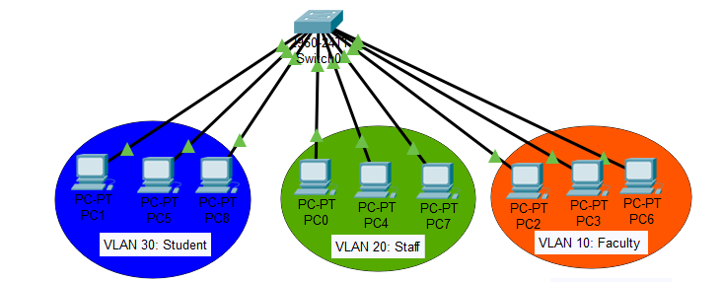

With the help of VLAN, we have separated our single network in three small networks. These networks do not share broadcast with each other improving network performance.

VLAN also enhances the security. Now faculty department cannot access the staff and student’s department directly.

**Task 1:**

TOPOLOGY: Consider the below Topology where one switch is connected with three different departments.



**Step 1:** Build this topology on Packet Tracer and write down your observation in terms of Ping, Broadcast and Collision domain. You can choose any one network address such as 192.168.10.0 or 10.0.0.0 and assign IPs from that network to all PCs. Mention network address and IPs of all devices in Network topology and attach its screenshot below.

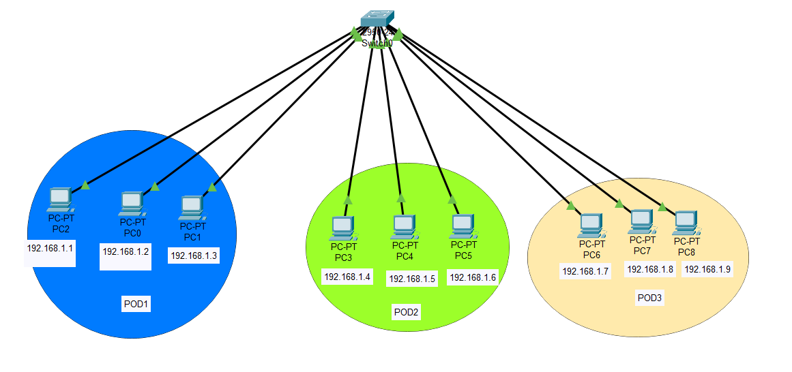

**Ping test:**

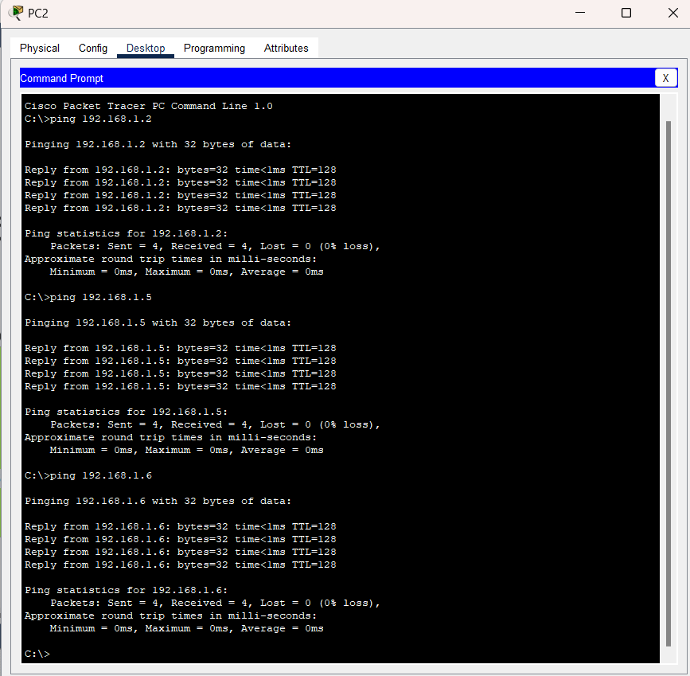

**Broadcast test:**

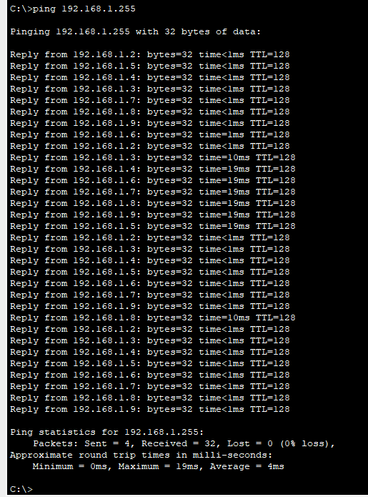

In this network topology, all PCs are connected to a single switch with IP addresses in the same subnet enabling successful ping responses between all devices. The entire network shares one broadcast domain, meaning any broadcast message, like a ping, is received by all other devices. However, since the switch creates separate collision domains for each port, no packet collisions occur.

Step 2: Run show VLAN brief command in privilege mode and mention How many VLANs are there and mention number assigned to them? Write down number of ports/interfaces assigned to each VLAN?

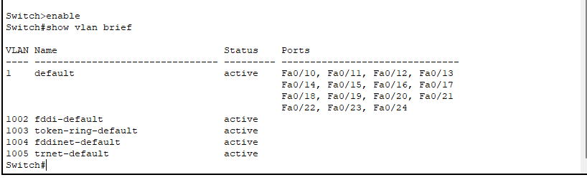

• VLAN 1 (default) is the only VLAN with ports assigned (ports Fa0/10 through Fa0/24).

• The other VLANs (1002, 1003, 1004, 1005) are active but have no ports/interfaces assigned to them.

You can create VLAN 10 for faculty on switch 0 by using below commands. Similarly, Create VLAN 20 & 30 on Switch for Staff and Students respectively.

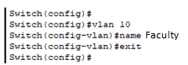

Run show VLAN brief command again and write down your observation.

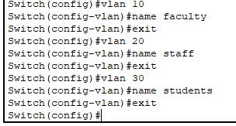 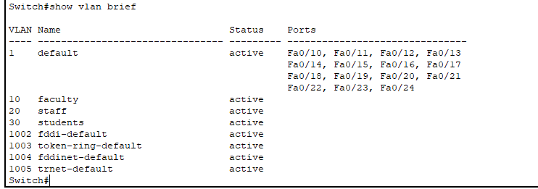

In this configuration, we created three new VLANs were created: VLAN 10 (faculty), VLAN 20 (staff), and VLAN 30 (students), all of which are active but currently have no ports assigned. Additionally, the output shows the default VLAN 1, which still has ports Fa0/10 through Fa0/24 assigned to it. Other default VLANs, such as VLANs 1002 (fddi-default), 1003 (token-ring-default), 1004 (fddinet-default), and 1005 (trnet-default), are also active but without any assigned ports. This shows the creation of custom VLANs with specific names and status but without any ports being moved from VLAN 1 yet.

**Step 3:** Enable the Access Ports & assign ports/interfaces of switch to respective VLAN. Go to option-Preference and check on “Always show port labels in Logical Workspace”. Now you know which interface of switch is connected to end device (PC).

Note: Make sure to note which interface of switch is connected with PCs in same VLAN. You have to assign same VLAN to those PCs which are in a single VLAN through its interfaces. After enter in interface fast Ethernet 0/1, it is important to run “no shutdown” command to up the link.

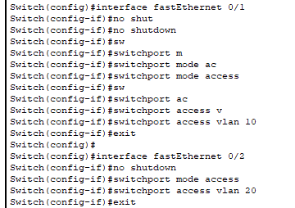

Similarly, assign remaining ports of switch connected to VLAN 10, 20 and 30. Run show VLAN brief and write down your findings and attach screenshot below.

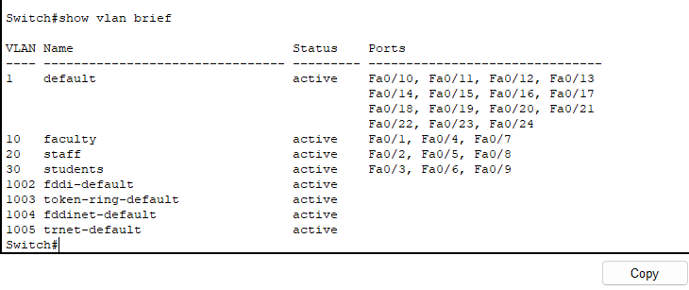

Ping any two PCs of VLAN 10 and write down your observation.

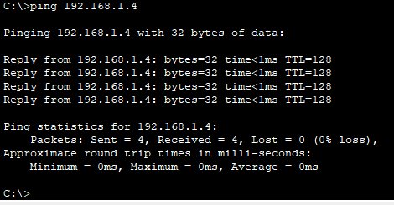

Ping any PC of VLAN 10 to any PC of VLAN 20 and write down your observation.

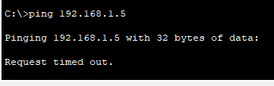

**Task 2:**

TOPOLOGY: Consider the following Lab Topology where two Switches are connected to each other and have different department PCs connected to them:

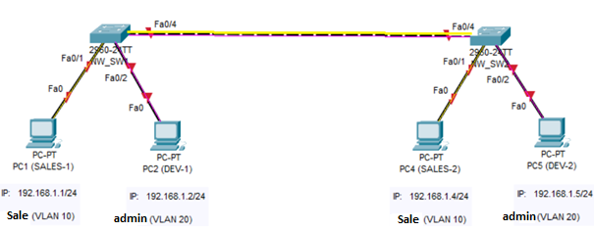

**Step 1:** Build this topology on Packet Tracer and write down your observation in terms of Ping, Broadcast and Collision domain.

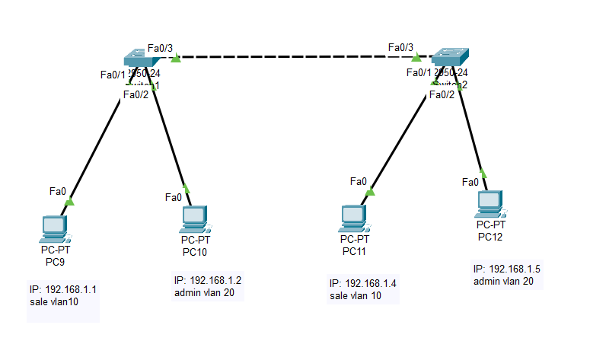

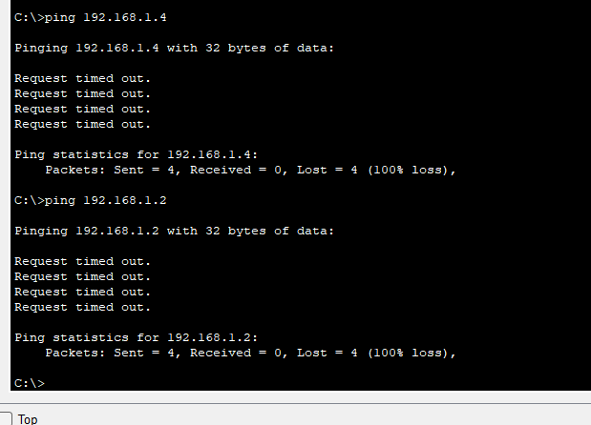

**Observation:** From the network topology and the results of the ping test we observed that the devices in different VLANs are unable to communicate with each other. The ping requests to the IP addresses in other VLANs, such as 192.168.1.4 (PC11) and 192.168.1.2 (PC10), are timing out. This indicates that the network is correctly segmented by VLANs, and no inter-VLAN communication can be done.

**Step 2: Configure VLANs on SW1 and SW2**

**Attach screenshot of your Network Topology and fill the below table as per you network requirements.**

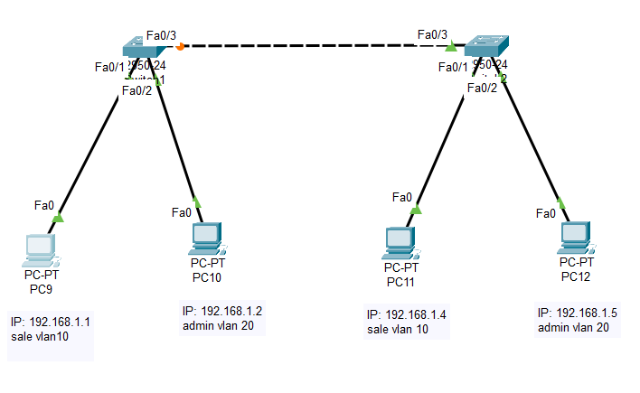

|  |  |  |
| --- | --- | --- |
| **Device** | **Switch interface connected with PC** | **VLAN (to be assigned)** |
| **SW1** | Fa0/1 (connected to PC9) | VLAN 10 (Sales) |
| **SW1** | Fa0/2 (connected to PC10) | VLAN 20 (Admin) |
| **SW1** | Fa0/3 (Trunk connection to SW2) | Trunk (allow VLANs 10 and 20) |
| **SW2** | Fa0/1 (connected to PC11) | VLAN 10 (Sales) |
| **SW2** | Fa0/2 (connected to PC12) | VLAN 20 (Admin) |
| **SW2** | Fa0/3 (Trunk connection to SW1) | Trunk (allow VLANs 10 and 20) |

You can create VLAN 10 by using below commands. Similarly, Create VLANs on Switch 1 and Switch 2.

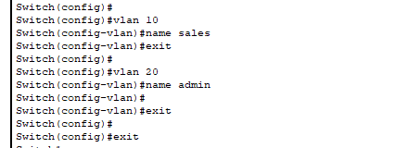

Enable the Access Ports & assign VLANs accordingly on SW1 and SW2:



Similarly, assign remaining ports to other VLANs.

Run **show Vlan Brief** command on both switches. Write down your observation and attach the screenshot below:

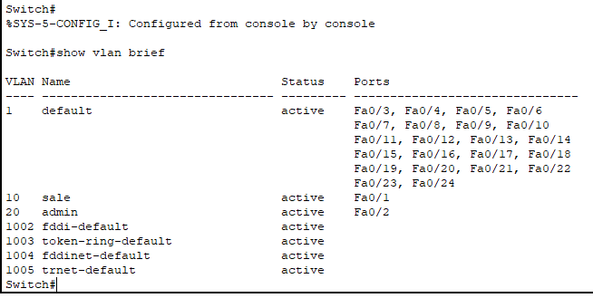

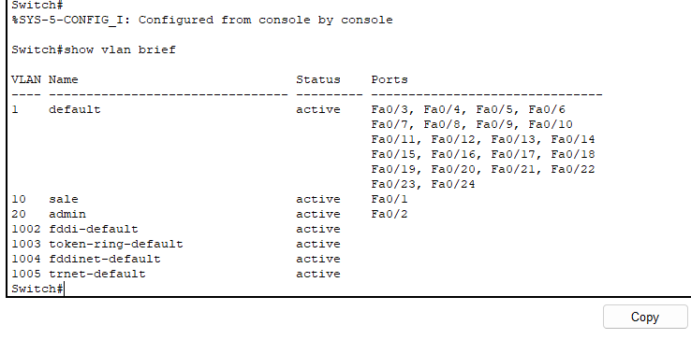The show vlan brief command output from both switches shows that VLANs 10 (Sales) and 20 (Admin) have been successfully created and are active. VLAN 10 is associated with port Fa0/1, while VLAN 20 is associated with port Fa0/2 on both switches. The remaining ports on the switches are part of the default VLAN (VLAN 1).

**Verification of VLANs:**

1. Ping PC1(SALES-1) to PC4(SALES-2)
2. Ping PC2(admin-1) to PC5(admin-2)
3. Ping PC1(SALES-1) to PC2(admin-1)

Comment on above results.

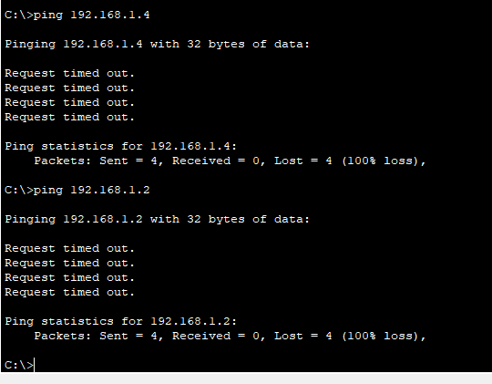

Configure the Trunk Ports & Allow the VLANs through them: Check which interface is used to connect two switches and ‘ll make it trunk port.

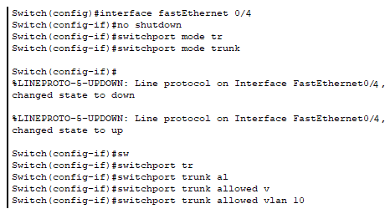

**Verification of VLANs:**

1. Ping PC2(admin-1) to PC5(admin-2)
2. Ping PC1(SALES-1) to PC2(admin-1)

Comment on above verification.

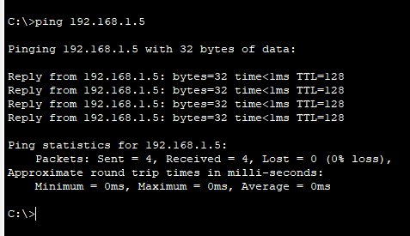

The ping from **PC2** to **PC5** was successful, confirming communication within VLAN 20. However, the ping from **PC1** to **PC2** failed, indicating a problem with inter-VLAN routing, which may require checking the router or VLAN configurations.

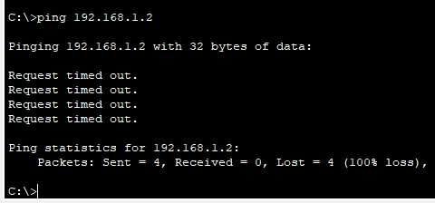

Now allow VLAN 20 in trunk mode and note down your observation.

|  |
| --- |
| When vlan 20 was allowed in trunk mode the admin 1 was able to communicate with admin 2. (checked through ping) screenshot is attached above. |

What do you understand by Access and Trunk port?

An **Access port** is a switch port that is assigned to a single VLAN and carries traffic only for that VLAN. It is typically used to connect end devices like computers or printers to the network. Traffic passing through an access port is not tagged with any VLAN information. A **Trunk port,** on the other hand, is used to carry traffic for multiple VLANs between switches or between a switch and a router.

**Run show interface trunk command in privilege mode and discuss the results**.

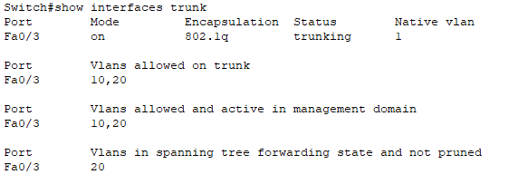

The show interfaces trunk command output shows that **Fa0/3** is configured as a trunk port. The port is **trunking** (active trunk mode), allowing VLANs **10 and 20** to pass through. The **native VLAN** is set to VLAN 1, which means untagged traffic will be associated with VLAN 1 by default. The VLANs allowed and active on the trunk are **10 and 20**.

After checking the above tasks to RA. Remove the configured VLANs, Assign the interfaces back to VLAN 1. Write down the commands below and attach screenshot too. Check this to RA.

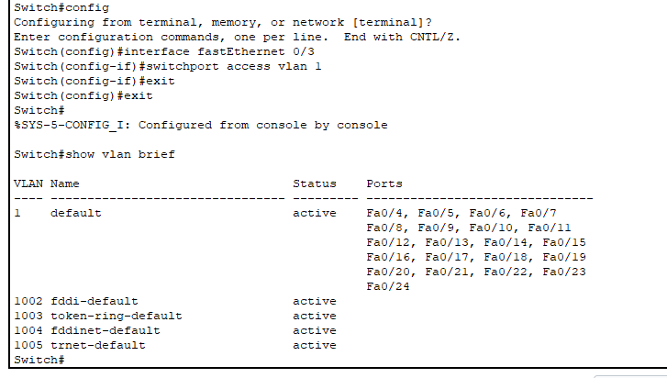

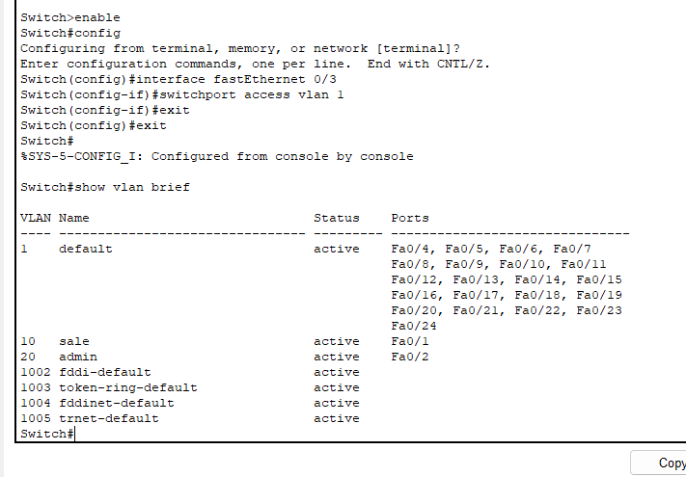

**Post Lab:**

**Task 1: If I want to communicate between two VLANs, propose the changes in Task 2 topology and how you ‘ll configure it. You have to provide labelled Network topology, commands and attach screenshot of successful ping in different VLANs.**

**Configuration of router:**

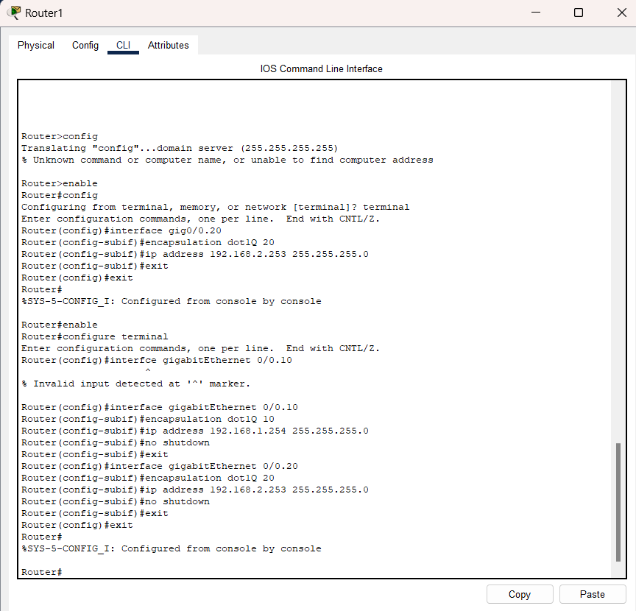

**Configuration of switch1:**

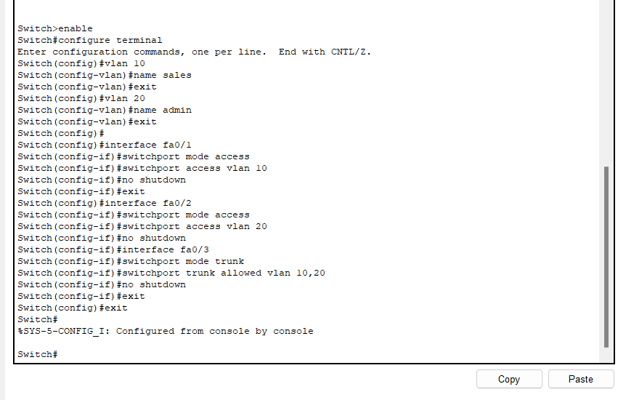

**Configuration of switch 2:**

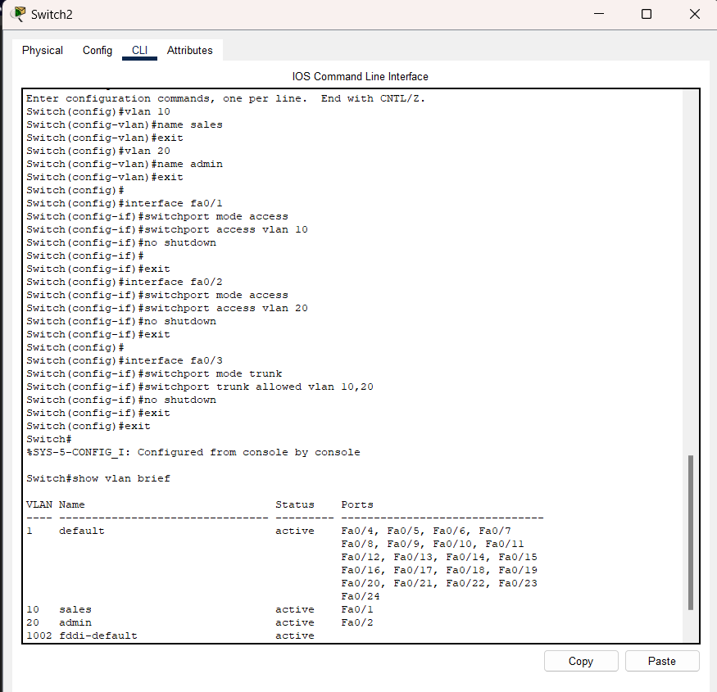

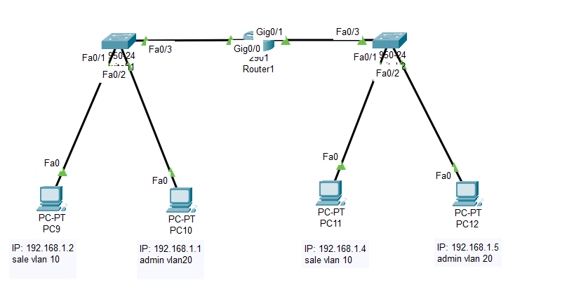

**Pinging vlan 10 to vlan 20:**

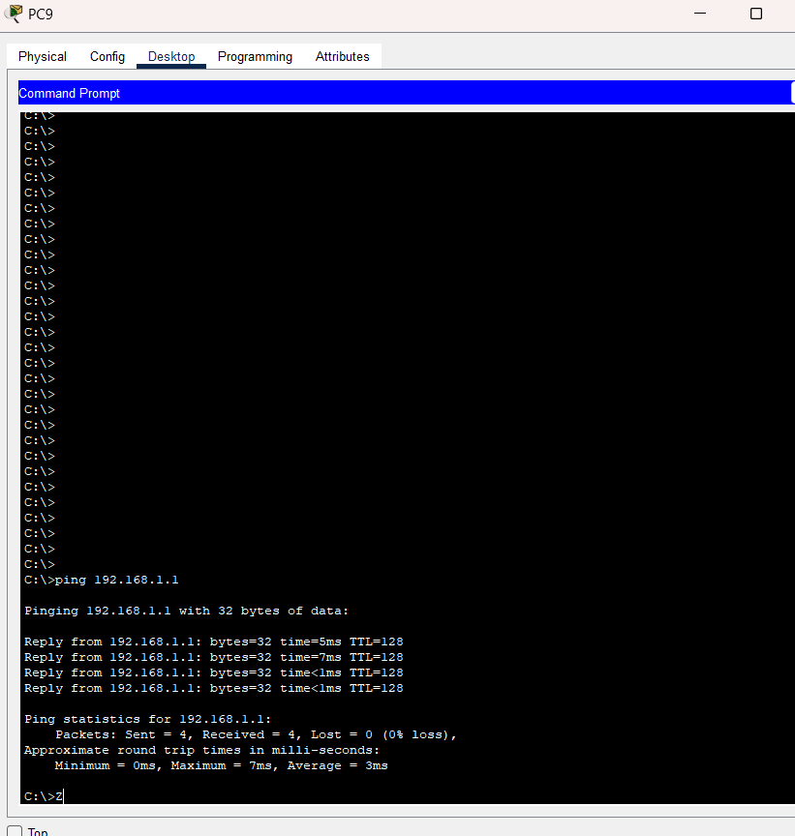

**Lab Evaluation Assessment Rubric**

**EE-424 Lab 4**

|  |  |  |  |  |  |
| --- | --- | --- | --- | --- | --- |
| **#** | **Assessment Elements** | **Level 1: Unsatisfactory**  **Points 0-1** | **Level 2: Developing**  **Points 2** | **Level 3: Good**  **Points 3** | **Level 4: Exemplary**  **Points 4** |
| **LR2** | **Program/Code/ Simulation Model/ Network Model** | Program/code/simulation model/network model does not implement the required functionality and has several errors. The student is not able to utilize even the basic tools of the software. | Program/code/simulation model/network model has some errors and does not produce completely accurate results. Student has limited command on the basic tools of the software. | Program/code/simulation model/network model gives correct output but not efficiently implemented or implemented by computationally complex routine. | Program/code/simulation /network model is efficiently implemented and gives correct output. Student has full command on the basic tools of the software. |
| **LR5** | **Results & Plots** | Figures/ graphs / tables are not developed or are poorly constructed with erroneous results. Titles, captions, units are not mentioned. Data is presented in an obscure manner. | Figures, graphs and tables are drawn but contain errors. Titles, captions, units are not accurate. Data presentation is not too clear. | All figures, graphs, tables are correctly drawn but contain minor errors or some of the details are missing. | Figures / graphs / tables are correctly drawn and appropriate titles/captions and proper units are mentioned. Data presentation is systematic. |
| **LR9** | **Report** | All the in-lab tasks are not included in report. | Most of the tasks are included in report but are not well explained. All the necessary figures / plots are not included. | Good summary of most of the in-lab tasks is included in report. The work is supported by figures and plots with explanations. | Detailed summary of the in-lab tasks is provided. All tasks are included and explained well. Data is presented clearly including all the necessary figures, plots and tables. |
| **AR2** | **Attendance** | Marked attendance and did not attend the lab or left very early. | Present but very late (31-60 minutes) or left early (31-60 minutes) without completing the tasks. | *Present but late (15-30 minutes), or left early (30 minutes) without completing the tasks. | Present and entered the lab on time and left on time. |
| **AR4** | **\*Report Submission** | Late submission after 1 week and in between 2 weeks. | Late submission after 2 days and within a week. | Late submission after the lab timing and within 2 days of the due date. | Timely submission of the report and in the lab time. |

**\*Report:** Report will not be accepted after 1 week of due date